8086 DIVISION

AIM: To write an assembly language program 16 bit addition using 8086 processor.

ALGORITHM:

1. Start the program.
2. Load SI with memory location.
3. Move data of SI to AX.
4. Add AX with BX.
5. Increment SI.
6. Move data from AX to SI.
7. Stop.

PROGRAM:

MOV AL, 4 ; AL = 04h

MOV BL, 2

DIV BL ; AX = 02h (02)

; print result in binary:

MOV bl, al

MOV cx, 8

print: MOV ah, 2 ; print function.

MOV dl, '0'

TEST bl, 10000000b ; test first bit.

JZ zero

MOV dl, '1'

zero: INT 21h

SHL bl, 1

LOOP print

; print binary suffix:

MOV dl, 'b'

INT 21h

; wait for any key press:

MOV ah, 0

INT 16h

RET

INPUT:

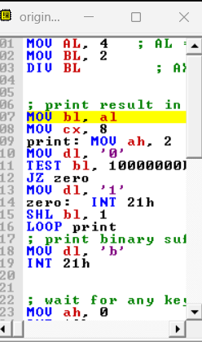

OUTPUT:

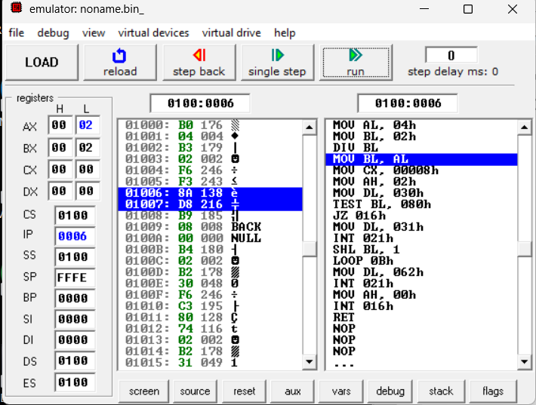

RESULT:

Thus the program was executed successfully using 8086 processor.